1. Checking in which shell we are in
2. Checking available shells
3. Change the shell
4. Create a directory to use for bash scripts

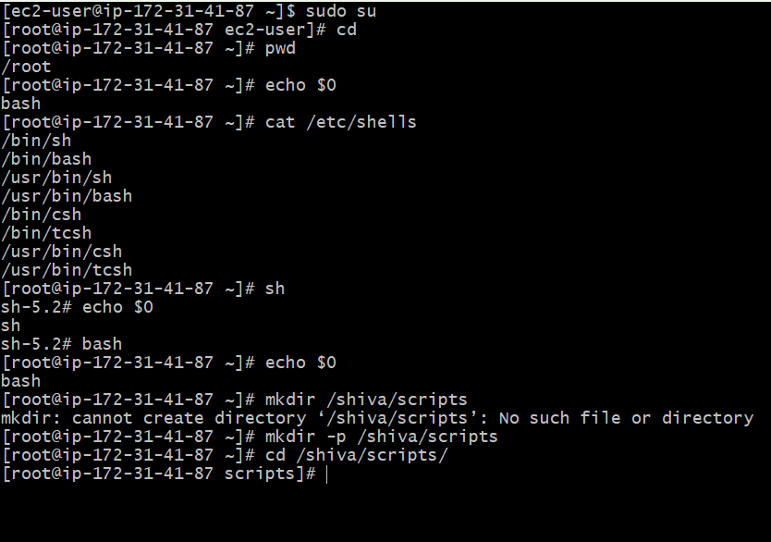

Give 755 permission to execute bash file with ./

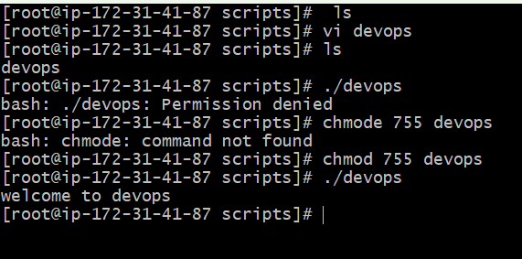

Create files with .bash to understand the bash files

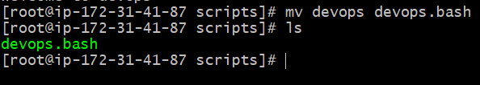

Basic Script format:

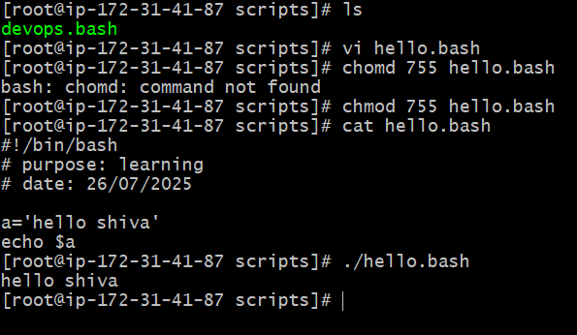

Sequence of the script (commands):

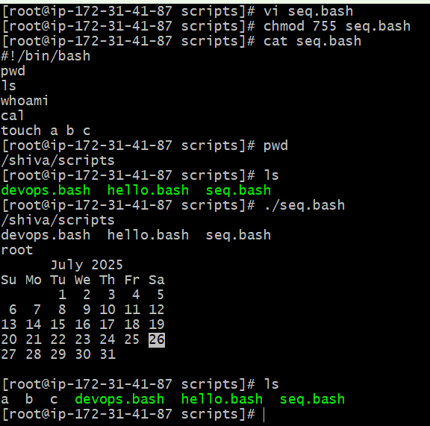

Admin tasks:

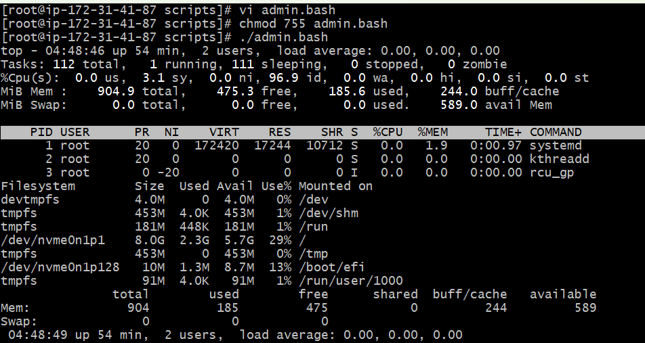

Variables task:

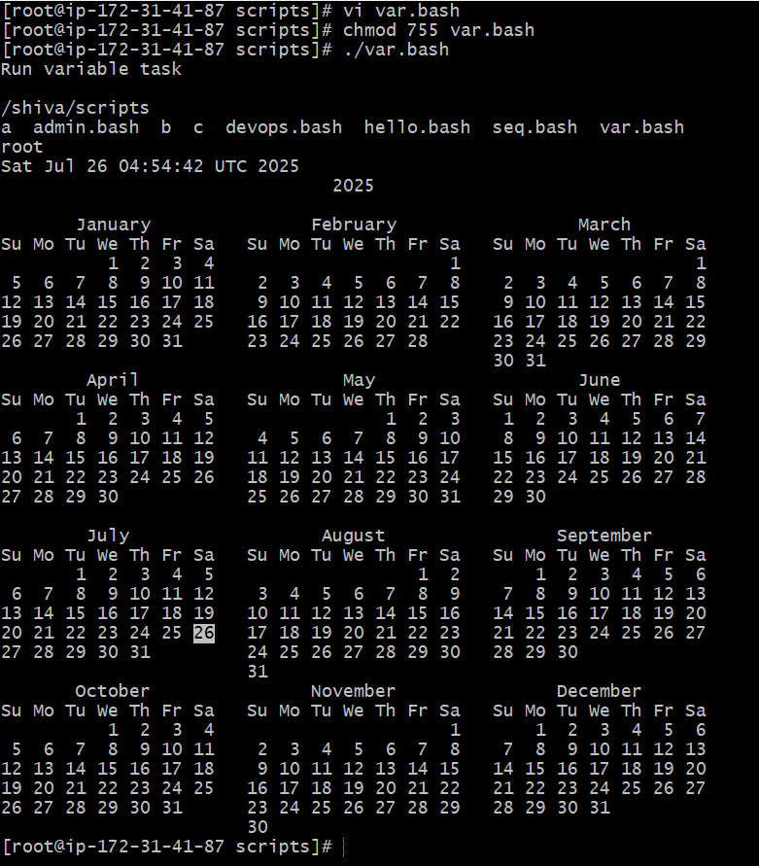

Input/Output Task:

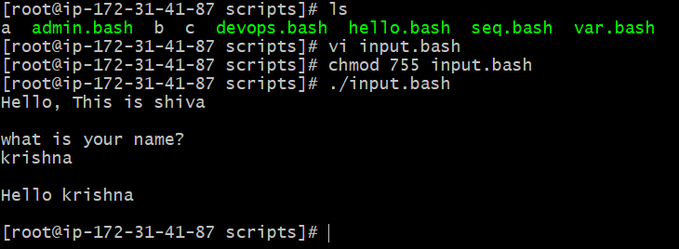

Displaying Hostname:

